Sending vouchers to Essilor via Annapurna

Enabling voucher entry in Annapurna.
- Navigate to Settings, Settings and search voucher in the filter.
- The option Allow Voucher Entry needs to be ticked, click update and the option should now show in order entry (a log out may be required to view the update).

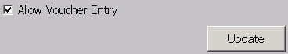

- The version of Annapurna required for this process is V2.88.

Entering a voucher in Annapurna.
In the order entry window there is an option to apply a voucher code to an order, this is used for Essilor as part of any voucher promotions. For example buy one get second pair half price.

- To apply a voucher to an order, click the present icon (located next to additional charges in the order entry window).

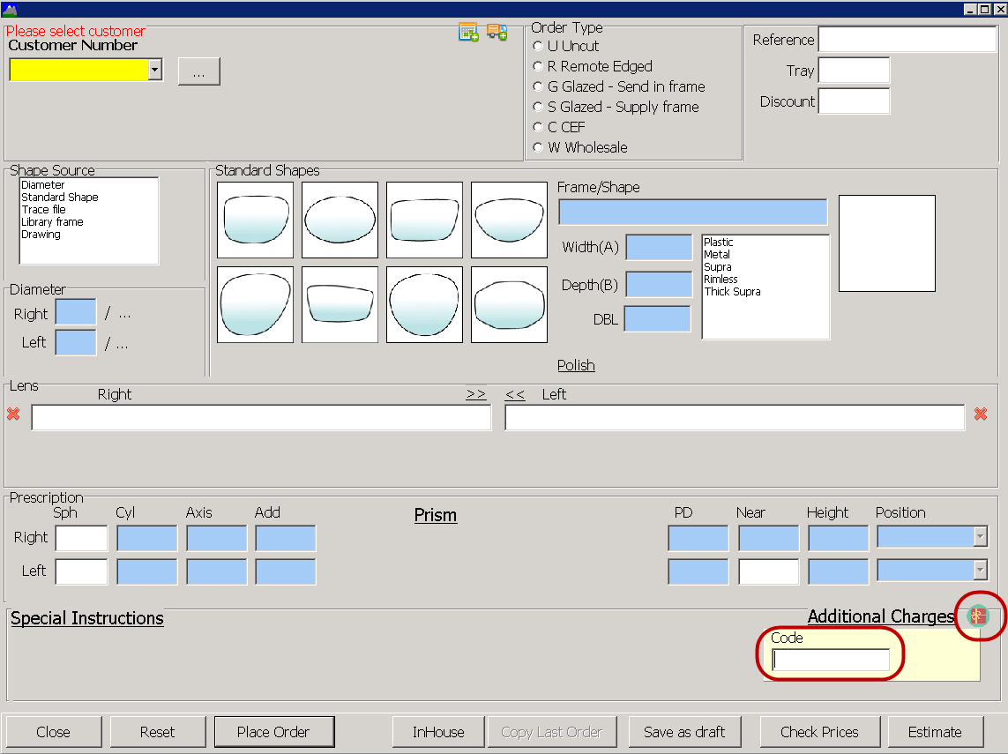

- Enter the voucher code into this field.
- If the voucher starts with a CN, CF or XP an additional field for Version number will display. The higher priced order needs to have 1 entered into the version field; the lowest priced job should have 2 entered in the version field.

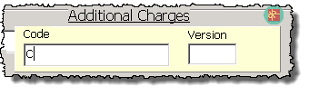
NOTE: For the Crizal campaign the higher priced job (Version 1) must have a Crizal coating included on the order.

Sending the orders to Essilor in the correct order.
- Navigate to Send RX to supplier from the Purchasing menu.

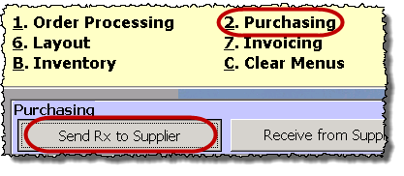
- Select the configuration tab and Essilor from the community list.

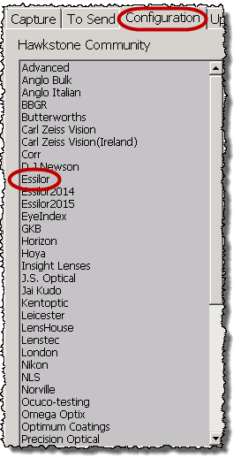

- Apply a tick to the Confirm Sending tick box and click Update (a log out may be required to apply the change).

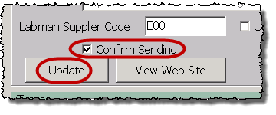

- Once this selection is made a new process will apply for sending orders to Essilor.

Ensuring the jobs get sent in the correct order to Essilor.

Sending Version 1 voucher jobs.
- Within Purchasing, select Send RX to supplier.

- Capture the job/tray number within the Capture tab, add remote edging where required by applying a tick to Remote Edge and select Order Lenses.

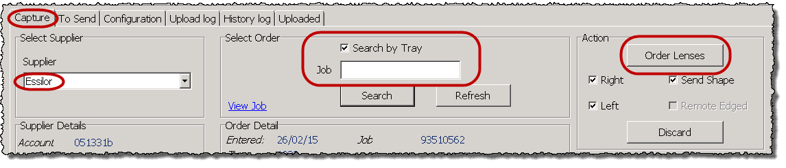

- On the ‘To send’ tab click Send Order for highlighted and view inbox for highlighted.


- A holding screen will display to show the list of jobs to be sent to Essilor.

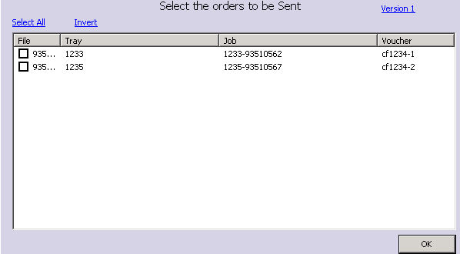
Note: Jobs without Voucher numbers can be selected by the tick boxes, jobs with Voucher number cannot be ticked.

- Click Select All to choose all non voucher orders.

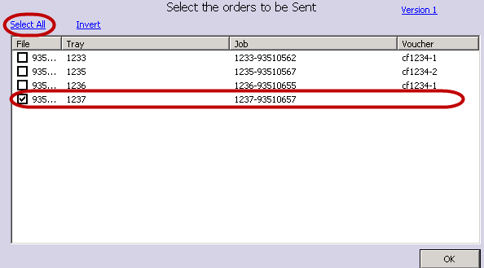

- If there are Version 1 jobs in the holding area click the Version 1 link in the top right hand corner to apply a tick to these jobs. Click OK to upload to Solenzara.

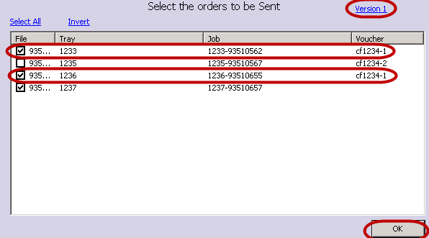

- This now means all non voucher and Version 1 voucher jobs are uploaded ready to be sent to Essilor through Solenzara.

- The version 1 jobs should now be confirmed through Solenzara to Essilor.

- Version 2 jobs must now be held in the holding box for 30 minutes before confirming to Essilor.

Sending Version 2 voucher jobs.
- Navigate to the ‘To send’ tab within ‘Send RX to Supplier’ and click Send Order for highlighted.

- The holding box should now display.

- Click select all to send all non voucher jobs and choose the Version 2 link to upload the Version 2 vouchers to Solenzara.

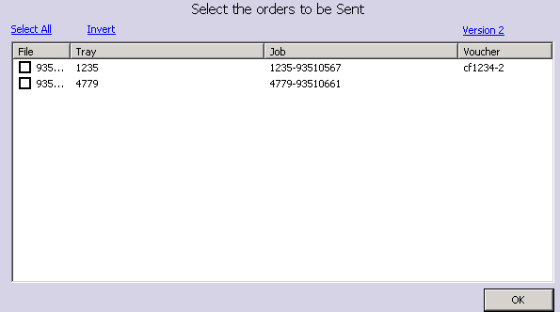

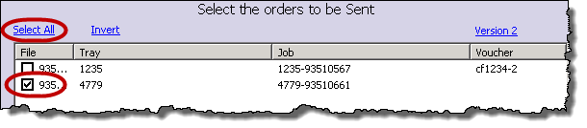
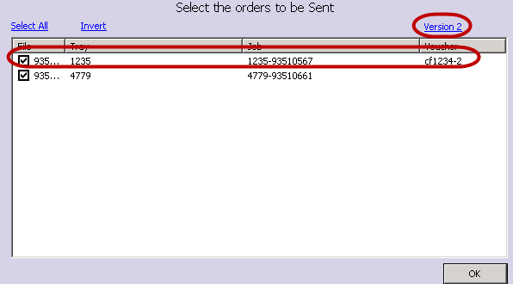

- The version 2 jobs can now be confirmed to Essilor from Solenzara.

Note: Even with these checks, it is still possible to send a Version 2 job first if the Version 1 has not been entered into Annapurna so care still needs to be taken with jobs being sorted before Order Entry.

Checking the voucher details in Solenzara.
When the order is uploaded to Solenzara (the web service which sends the orders to suppliers), you can check that the voucher has been applied.

- To check the voucher details have been uploaded successfully to Solenzara select an individual order and click Process Manually.

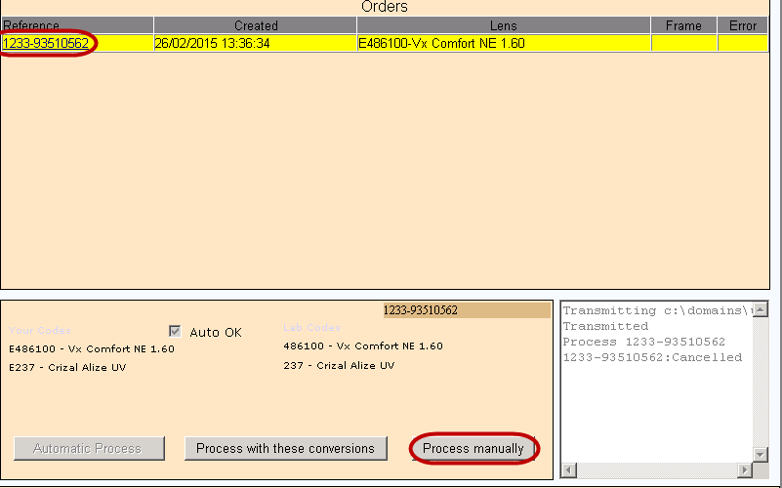

- Click the special instructions link to expand this section.


- The voucher tick box should have a tick applied and the voucher (comments field) will have the voucher number followed by -1 for version 1 and -2 for version 2.

