Setting Annapurna to Sell Semi-finished lenses.

Defining the semi-finished for sale.

The lens is defined in the lenses data.

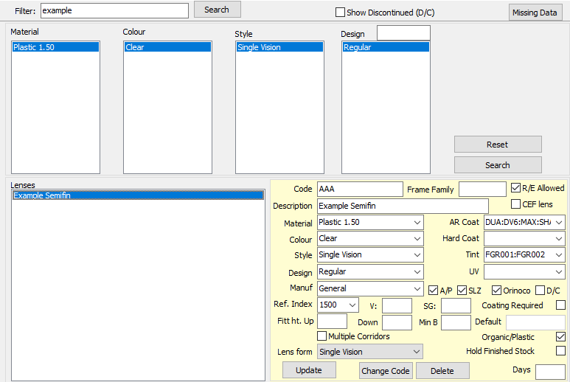

The Semi-finished bases are defined in the ranges.

In ranges screen / quick add – add a diameter.

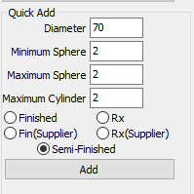

Press Add.

Now a diameter exists, click on sem-finished.

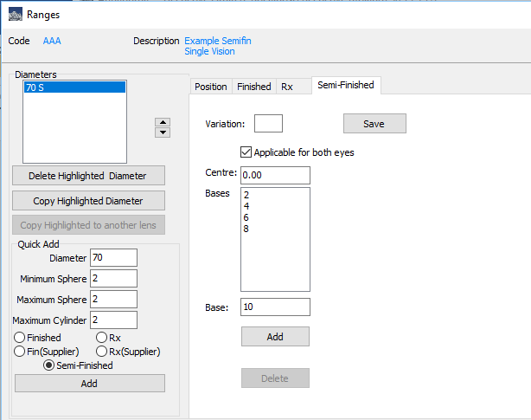

For each base, add it in and press Add.

The variation and centre thickness are only used if the lens is sold in thick and standard form. As, it is probable there will be a different price then this variation should be set as a different code.

In the Position, define the add range.

Save the Ranges.

Deploy the data.

In Settings – Pricing there is a setting “Sell Semi-finished”. This should be ticked.

This will then enable a new filter in the Commercial / Prices screen.



Prices are entered

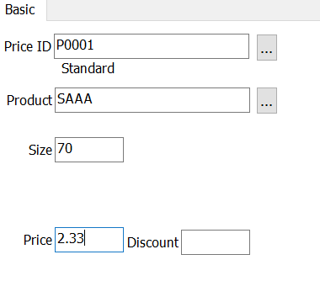

The Product code S+Lens code. This is so that the same product can be sold as Lens or Semi-finished. In this example, for Lens sale the code is LAAA and the Semifinished is SAAA.

Order Entry.

Wholesale Lens is selected. The options will now include semi-finished and finished.

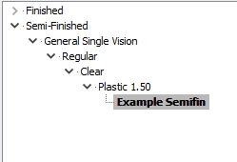

Select the lens and enter the product details.

The lines will then appear in the main screen.



The order is then completed and processed in the same manner as a finished wholesale order.

____________________________