Voucher entry through Solenzara

Solenzara has been updated to Version 153. To enable the voucher feature through your labs Solenzara site:

- Log in to Solenzara with the labs admin credentials.
- Click Configure followed by Site

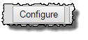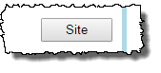
- Next choose More Options

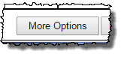
- Navigate to the Special Instructions box and apply a tick to the Voucher field.

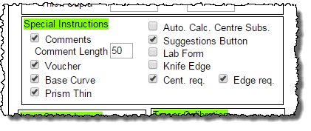
- Click Save and Close, log out and back in and your lab is now set up to receive voucher orders directly from customers into Annapurna.

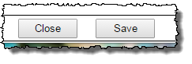
- Customers would enter the order and click on the Special Instructions link.

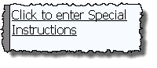
- Apply a tick to the voucher tick box, the voucher (comments field) will then display. The voucher number should be entered followed by -1 for version 1 and -2 for version 2.

Note: In Solenzara, there is no checking for the format of the voucher number, it is simply saved and passed on to Annapurna. If the voucher is entered in form xxxxxx-y then the y will be treated as the version number in Annapurna. Version 1 is the full price item, Version 2 is the one that receives the promotion.

