## VCA Device Control Shape.

### Background.

It is necessary to make sure that the tracer produces the correct results. This is done by running the tracer calibration process on a regular basis.

Also, VCADevice program has a feature to make a control trace. This is the first trace on each day and the circumference from this trace is compared to a master trace. If the circumference is within 0.05mm then the tracer is making consistent trace. If the value is greater than this then a calibration should be made. The master trace is normally the jig provided for calibration by the tracer manufacturer.

### Configuration.

In Device Settings, there is a tick box.

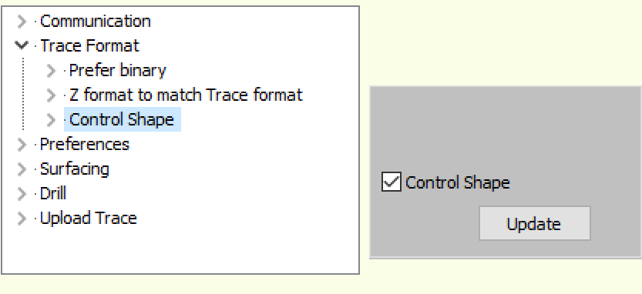

When this is set then on the communication screen, there is on the main screen a message to indicate that the control shape is to be traced. This will appear on the first trace of the day also.

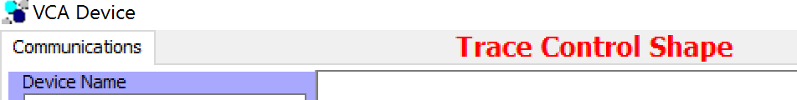

When the Control Shape has been traced for the first time then the trace is saved.

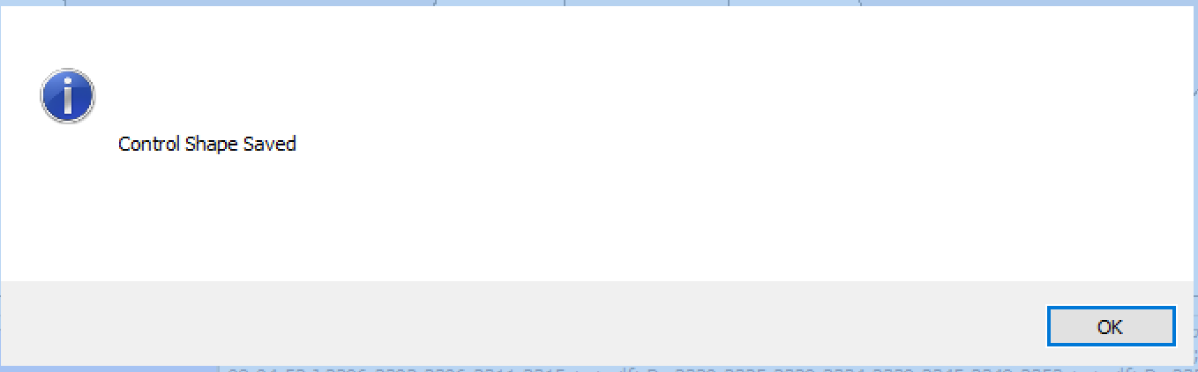

### Daily.

On the following day, the first trace is checked against the control shape. If it matches then the following is shown.

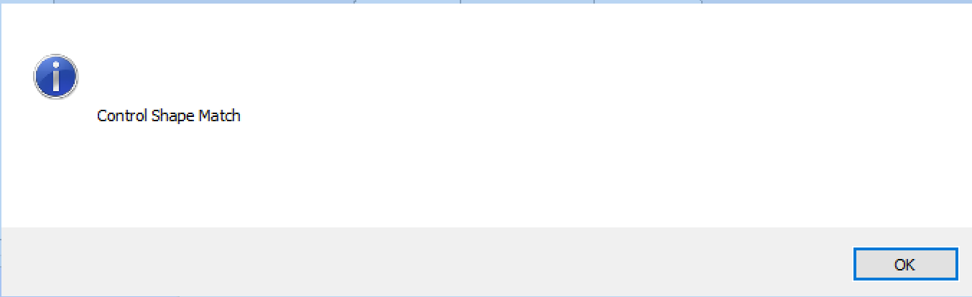

The date of the control shape is updated.

If the control shape does not match then a calibration should be done.

### Reset Control Shape.

When the calibration is finished then a new Control Shape needs to be made. This is done by pressing Control Shape on the left hand side.

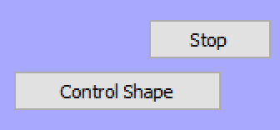

This will bring up a screen to show the Control Shape.

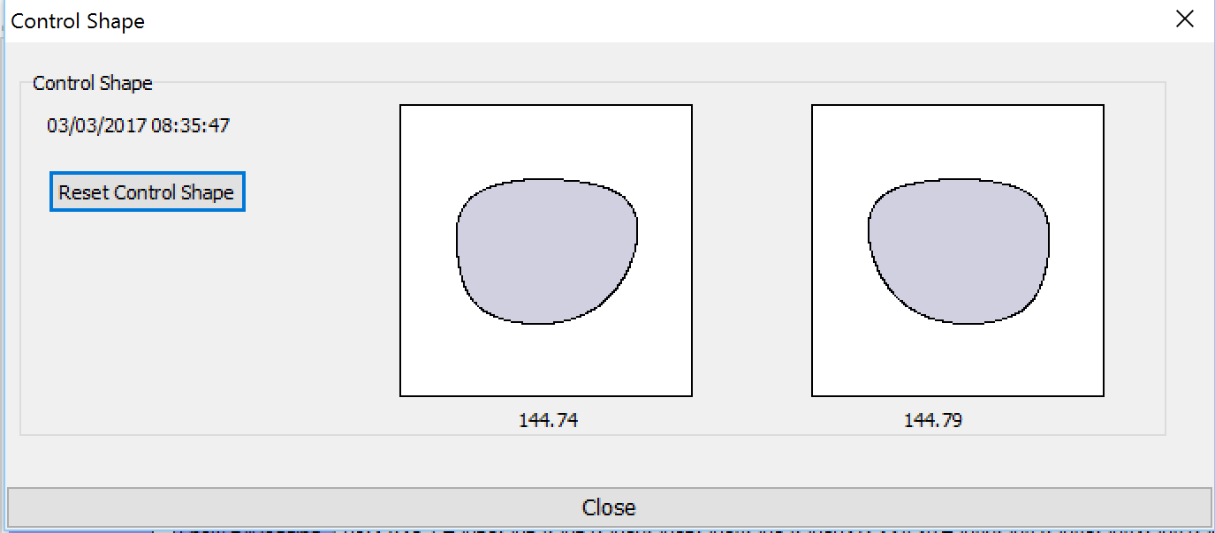

Press Reset and enter the password Reset.

### Summary.

This concludes how the Control Shape is managed.