Completed Orders.

Introduction.

This document describes how to set up a system for pricing lenses from a price list selected by the frame.

Firstly, there is a configuration that needs to checked.

In Settings, this needs to be unticked.

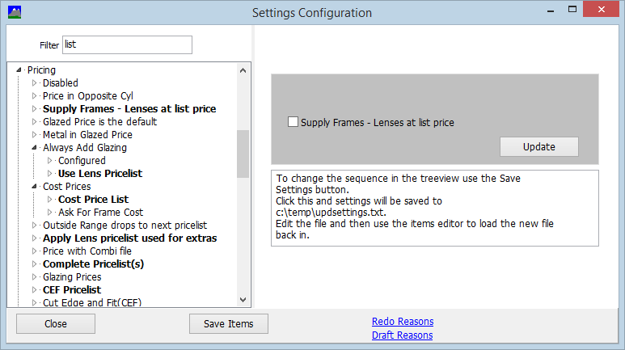

Complete Pricing.

The aim is to use the complete pricing method. In this the frame is sold at the usual price but the lenses are reduced to an agreed price. This is done by implementing a complete pricelist so let's add this.

Go to Settings / Pricelists and add pricelist 101 and indicate that this is the complete pricelist in the description.
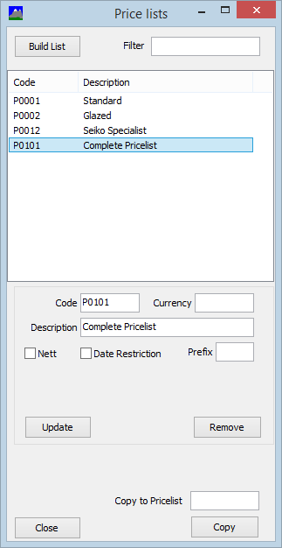

Originally Complete Pricing was connected to the customer so we need to turn that off by a setting that is also in the Pricing section.

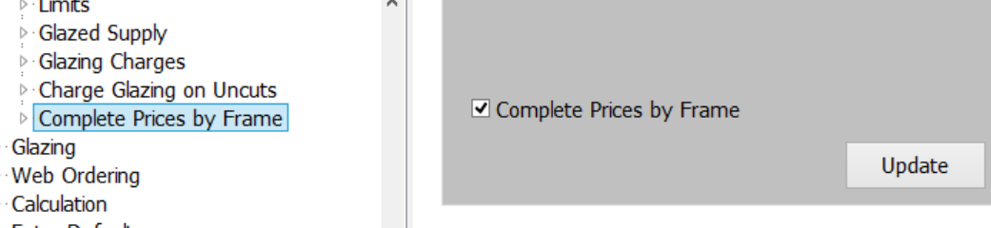

Frames.

There are two approaches. The individual models could be created or alternatively a holding frame to indicate the brand, frame type and price can be created. Here is an example of the latter for Wolf Cubs.
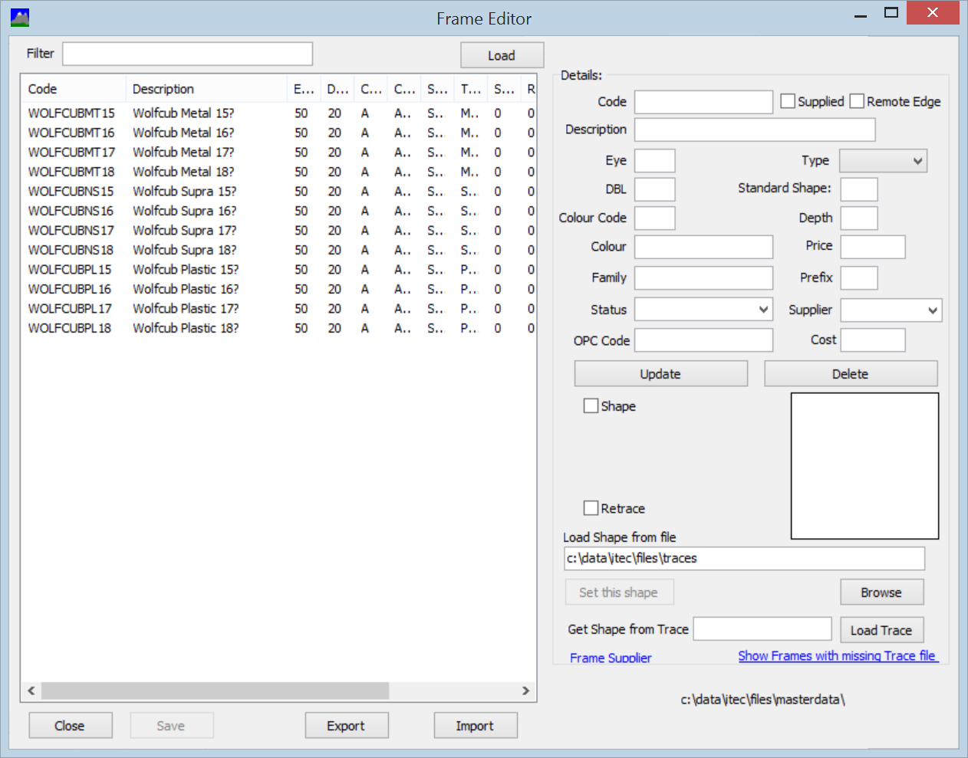
In this, the frame is given code WOLFCUBMT17 to indicate Metal and charged at £17. The description ends with ? This is important as Annapurna will then prompt for the correct description at order entry.

Lenses.

The next step is to set the lenses prices for those lenses that are in the promotion.

In this case 1.5 SV Stock on Pricelist 101 is £3.00.
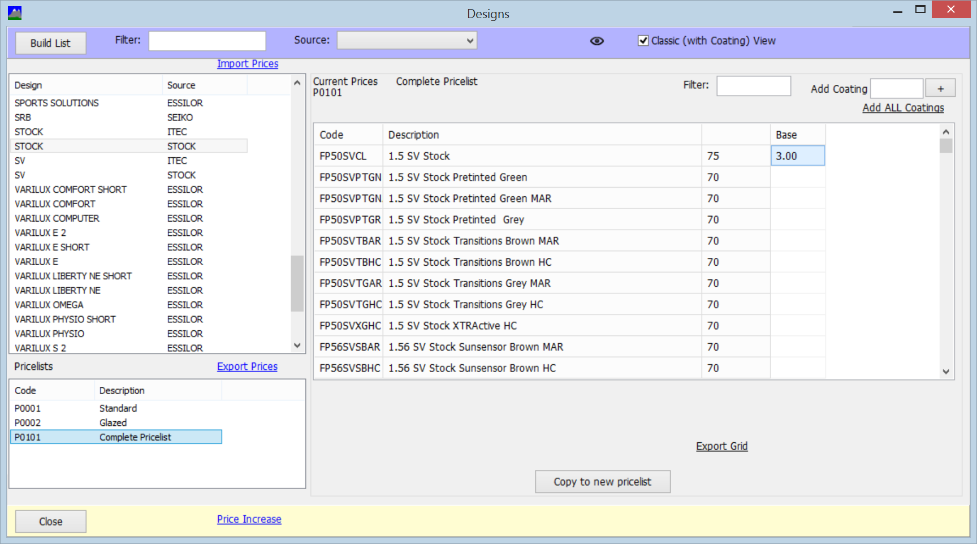

Setting Frames to use the Complete Pricelist.

The next step is to indicate the Complete Pricelist to use when the frame is chosen.

This is done by going into packages and in the top right there is
Click on this and the following screen is shown. The first word in the frame description is used to identify the appropriate price list. In the screen below, Wolfcub is set to use pricelist 101.

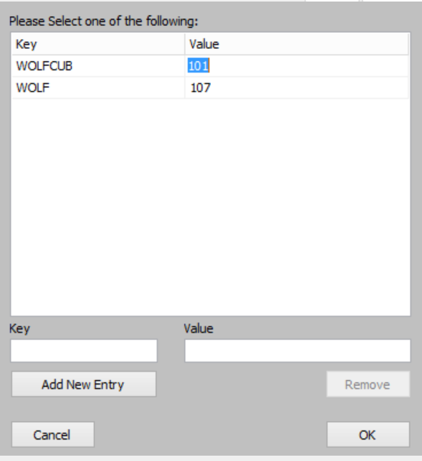

Order Entry.

When an order is entered then we can see that the lenses are priced using pricelist 101 as indicated by supplying a frame where the description starts with the word Wolfcub.
