Rx to Stock.

This document describes how stock lenses can be ordered from the supplier for Rx lenses.

Setting.

Under Settings / Web Ordering there is

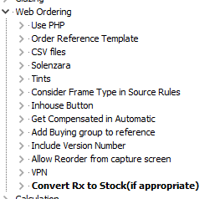

Convert Rx to Stock(if appropriate) needs to be ticked.

Supplier Configuration.

In the ‘order grabber’ configuration, a new link will appear.

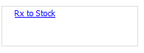

Clicking this for a supplier will open a screen or the data file can be updated directly. The file is in the form.

Supplier Rx code+Supplier Coat code = Supplier Stock code+Supplier Coat Code

e.g.

A123+NONE=S99901+NONE

This is to connect the Rx code to the Stock code.

Coating is included in the conversion file as Rx lens + coating can be mapped to a finished lens code that includes coating.

This will allow orders for the Rx code to be ordered from the stock code if appropriate. In order to see if appropriate then a range has to be defined.

This feature can also be used for ‘inhouse’ lenses. A data file still has to be made in the purchasing folder for the supplier as it appears in the lens selection screen.

Range.

It is necessary to define the range that can be supplied as stock.