Delivery Targets.

General delivery targets are set in Targets

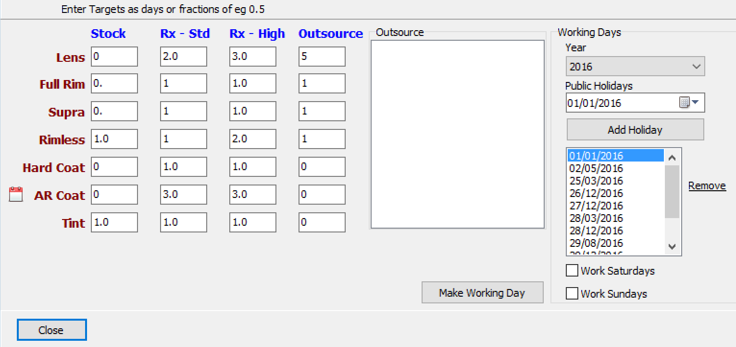
This is the target for prescription orders.

The lenses are divided into 4 categories.
Stock – the lens is in the finished range and the range indicates in house.
Rx-Std – the lens is not OurSourced (see below) and not Stock.
Rx – High – as Rx – Std but for higher indexes.
Outsource – the lens is Outsourced.

For Outsource a list of Outsources is given in the list. This list is taken from the manufacturer column in lenses.csv. Only those that are outsourced should be ticked here.

The total target time is taken as the total for the lens, for the glazing (one of full rim, supra, rimless)
for the coating (Hard or AR) and for the Tint.

Each of the categories has a target time based on the source of the lens. The target time can be percentage of the day so 0,5 means half a day.. The day is assumed to be 9 to 5.

In screen above an outsourced lens with Full rim glazing and coating will be 5 days+1 day + 0 day = 6 days. A Rx-High lens with Rimless and AR coat and Tint will be 3 + 2 + 3+ 1 = 9 days.

The time of the day when the order is entered so an order to take 0.5 days (eg Uncoated stock lens) then if the order is entered at 10:00 then the target will be the same day but entered at 16:00 then the target will be the following day.

If it possible to set working days for specific lenses by entering a number in the days in the Lens Data screen. Note putting zero here means zero days, leave the field blank for the defaults described above to be applied.

It is also possible to set working days for specific coating and tints by clicking the calendar icon by the AR Coat.

The number of days has now been calculated, this is converted into an estimated delivery date by the working day on the right hand side.

The Public Holidays and other shutdown days are entered on the right hand side for the year in question. The Work Saturdays, Sundays should be ticked if there are deliveries made on a Saturday and Sunday. As the purpose is to calculate the target delivery date these should only be ticked if there is a delivery on these days even if there is production taking place. Click Make Working day calendar. This can take a couple of minutes to do this (currently).

