New Macro Question Type.

A request has been received for dates to be included in the macro questions such as date of birth, date of last test.

This has been accommodated by adding a new question type – type 3.

This will prompt in Solenzara for a day, month, year values and in Annapurna for a date selection.

If the value needs to be passed in a Solenzara Webservice input then the value is passed in *yyyymmdd* format.

Here is the question as used by Zeiss.

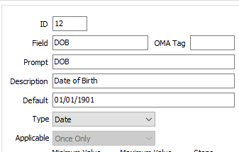

And a lens that uses this question

26207 ZEISS Progressive SmartLife Individual 1.5

The data in the Macros file for this question is

[Question12]

Field=DOB

OMATag=

Prompt=DOB

Description=Date of Birth

**QuestionType=3**

Applicable=1

Default=01/01/1901

Minimumvalue=

Maximumvalue=

Steps=

Mandatory=0

AllowNull=0

Disallowed=

Required=

__________________________________________________________________________