Automatically sending emails when a watched order is despatched.

Configuration

The setting Send Email when Watched Orders are completed needs to be ticked.

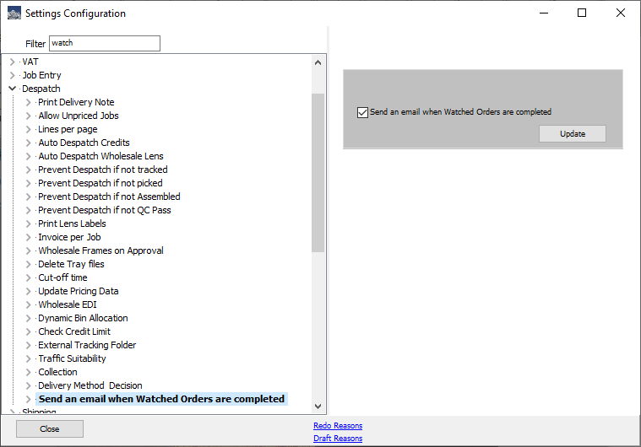

In the menu options Settings / Email there is an option for Watched Completed.

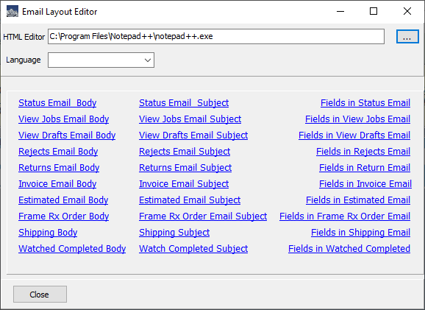

Click Watched Completed Body link to download and edit the template for the email in your specified editor.

Action.

An email is sent to the email address in the customer record when an order is processed through Complete Orders, Bulk Send and Despatch Router.

